



**IICT**

Assignment # 1



|  |  |
| --- | --- |
|  |  |

**Title: -Various Role of Computer in Different Public Sectors**

|  |  |
| --- | --- |
| *Submitted to* | *Zaffarullah Zafar* |
| *Submitted by* | *Hamza Mehmood* |
| *System Id* | *NUML-S21-23529* |
| *Subject* | *IICT* |
| *department* | *BS-SE (Evening)* |
| *Semester* | *1st* |

There are various works available in today’s modern era. One of the modernized sectors today is the business industry. Many business owners integrate the use of advanced technology to improve their communications and services. It enhances their transactions towards a broader audience to reach more people.

* *Computers are the competitive assets that a business organization could have. In this world full of digital devices everywhere, it is an advantage to have computers to accommodate all the data that you will need. Business infrastructures always see to it that they attend to the fast changing needs of the customers.*
* *If you are working in an office setting today, you might be introduced to the computers’ importance and function. Adding machines and digital devices in a business makes it more efficient and productive. No matter what business you have, the use of a computer is a huge part of its management.*
* *There are various works available in today’s modern era. One of the modernized sectors today is the business industry. Many business owners integrate the use of advanced technology to improve their communications and services. It enhances their transactions towards a broader audience to reach more people.*
* *Computers are the competitive assets that a business organization could have. In this world full of digital devices everywhere, it is an advantage to have computers to accommodate all the data that you will need. Business infrastructures always see to it that they attend to the fast changing needs of the customers.*
* *If you are working in an office setting today, you might be introduced to the computers’ importance and function. Adding machines and digital devices in a business makes it more efficient and productive. No matter what business you have, the use of a computer is a huge part of its management.*

**How can the uses of computers elevate the performance of a Finance organization?**

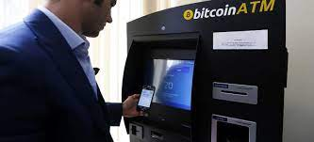Computers play a significant role in handling all of the world's money. Below are examples of how computers are used in the financial market and places dealing with money.

* **ATM** - When you make a withdraw from an ATM, you are using a computer.
* **Digital currency** - When depositing money in a bank, it is stored as a digital record. A computer keeps track of how much money is in your account.
* **Trading** - Stocks and commodities are traded using computers. In fact, today there are even thousands of computers using advanced algorithms that handle trading without needing humans.

**What are the Computer Devices used in the Banks?**

Any bank branches provide different financial services. It includes access to your bank account and personal information, offers investments, and money withdrawals and transfers, which can be accomplished using the Internet. Computers provide all these financial services to promote convenience for the customers. Here are some of the digital devices that modern banks are utilizing for their transactions.

**Mainframe Computers**

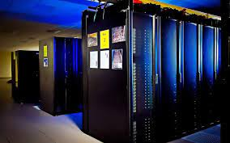

Most of the computers are working on their transactions with the use of computers. Furthermore, the bank’s mainstay remains the mainframe. Mainframe computers are considered as big iron. It is the major foundation of the bank’s operations. These are the common functions of mainframes.

* Stores all of the customer account data.
  + Executes complex data analysis of continuous changes in the financial markets.
  + Monitors the bank’s product offers and related interest rates and savings.
  + Connects with other mainframes at various branches around the world.

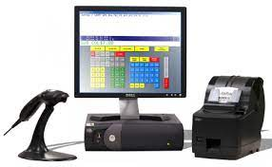**Teller Terminals**

Modern banks need a teller to provide the services for different national and international needs of the customers. Tellers communicate with worldwide bank users just like what mainframes do. All of these connections occur within the individual teller terminals. These terminals provide access to business and personal overseas bank accounts. It also works on wire transfers and payments to other types of bills.

**Digital Scanners**

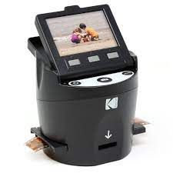Digital scanners are used in banks either as a stand-alone or attached to a larger computer. These digital imaging devices are beneficial for the operations of modern banking. Banks today use check scanners to deposit and transfer money. It makes digital scanning contributes to the betterment of financial services.

**Biometric Devices**

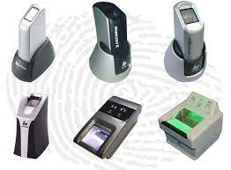Biometric devices work on verifying the identity of the bank user. When you press your thumb on the digital device, the computer will confirm your identity through your fingerprint. Because technology continues to be available, these biometric devices will soon be a typical computer device for banks worldwide.

Digital devices improve the services for both corporate and banking transactions. It creates a conducive environment to make every individual’s living at ease. These innovations provide more options for the business sectors to approach their customers in a variety of methods.

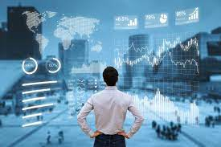**Business**

Business is another big sector for computers and most money earned and spent is done using a computer. Below are some of the examples of how computers are used in business.

* **Register** - If the business deals with selling goods to a consumer (e.g., a grocery store), a cash register, which is a computer, is used to complete transactions.
* **Workers computer** - Many businesses assign each employee a computer that allows them to produce work and solve problems for the company.
* **Server** - If the business uses computers, connects to the Internet, or handles e-mail and files, a server is used to help manage everything.

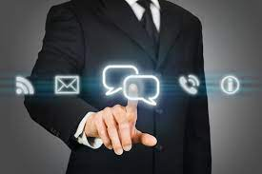**Communication**

Today's communication around the world is almost all digital and handled by computers. Below are examples of how computers are used in the communication industry.

* **Smartphone** - If you have a smartphone, you have a computer in your pocket.
* **E-mail** - More electronic mail (e-mail) is sent today than postal mail (snail mail), and computers handle all creation and distribution of that e-mail.
* **VoIP** - All voice over IP communication (VoIP) is handled and done by computers.
* **Computer-assisted speech** - Those who are disabled or cannot speak can use a computer to help them communicate. For example, Stephen Hawking uses a computer to communicated.
* **Voice recognition** - Voice recognition uses a computer to translate recorded audio into text or other data.

**Defense and Military**

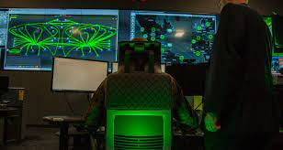

Many technologies (e.g., GPS and the Internet) were initially created or started with a defense-related purpose. Today, computers are still an important aspect of the defense industry.

* **Encryption** - Secure communication is vital in the defense industry and computers encrypt communications that should remain secret.
* **GPS** - Using computers with GPS allows the military to track people and equipment and is still used today.
* **Computer-aided flight** - Many of today's jets and other aircraft require computers to fly and operate.
* **Drones** - A drone is either autonomous or remotely driven and uses computers to operate.

**Education**

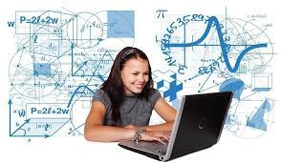As computers evolve, so does how computers are used in the education field. Below is a list of how a computer can be used in education.

* Internet - Connecting a student to the Internet gives him or her access to an endless supply of knowledge. As mentioned later, the Internet would not be possible without computers.
* Learning - Computers can also be used to help design and create a more visual learning experience for students. Using electronic whiteboards with computers can also benefit a student by giving them a more hands-on experience.
* Writing - Although reports can still be done using pen, pencil, or even a typewriter, a computer makes it easier to write, format, save, share, and print reports.
* Keep records - Computers track students’ scores, identify struggling students, and create a final report.
* Testing - Computers can assist students and teachers with the testing process by stepping the student through a series of questions and keep track of the results.

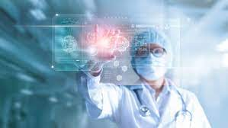**Medical**

The medical, or health care, field is another place where computers are vital and used every day. Below are examples of how computers help those in the medical field.

* Medical records - More and more medical records are being digitally stored. Storing these files digitally allow for quick access and transfer of medical information so doctors can know your history.
* Monitoring - Computers help with monitoring a patient and can alert staff in the case of an emergency.
* Research - A lot of the medical research is computer assisted. Without the assistance of a computer, it would either not be possible or take too long to be viable.
* Diagnosis - Computers can assist in the diagnosis of a patient, from gathering a patient's history and conditions to comparing that information against a database of existing information.
* Surgery - Although most surgery is still done with humans, it is becoming more practical and accessible for computer robot-assisted surgery. After being programmed, these robots can make surgery more accurate, faster, and less prone to human errors.

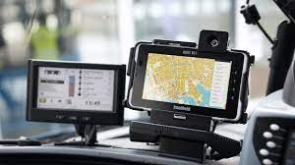**Transportation**

Computers also play an important part in transportation. Below are a few examples of how computers help the transportation field.

* Cars - Most may not realize it, but all modern cars today have multiple computers that help control and manage the vehicle.
* Traffic lights - The traffic lights that help control traffic are all run by computers.
* GPS - Cars that include a GPS mapping system have computers for display and calculating routes.
* Airplanes - The airplanes that help transport millions of people and goods every year are filled with computers that help control the plane.
* Public transportation - Train, bus, subway, and all forms of public transportation are highly dependent on computers to manage traffic flow, monitor operation, and handle payments.
* Self-driving cars - Although relatively new, self-driving cars are becoming increasingly popular and rely on a computer to make all decisions on how to drive.

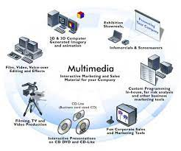**Multimedia**

Computers also play a significant role in video and audio. Below are examples of how computers are used in the film and audio industry.

* Editing - Once a movie, video, song, or audio track is created a computer can edit that media instead of having to manually make cuts to the film or audio track.
* CGI - Computer animation and CGI has become a norm in big budget films. To create these effects computers and sometimes server farms are used.
* Manipulation - Computers can manipulate pictures, video, and audio. For example, someone could use Adobe Photoshop to add or remove elements from an image.
* Recording and playback - Computers can also be used to assist in the recording of audio tracks and then selectively playback each audio track.
* Creation - Computers can also be used to help in creating new multimedia content. For example, creating 3D animation, 3D model, or a techno audio track can be done on a computer. After creating a 3D model, a 3D printer could also be used to build a product.
* TV, DVD, media players - Today's Smart TVs, DVD players, DVRs, etc., contain simple computing circuitry to connect the device to the Internet, run apps, and more.

**Robotics**

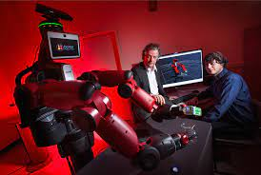The industry of robotics is exploding and computers once again play an important role in controlling robots. Below are examples of how computers help control robotic machinery.

* Control - Computers are what help control robotics. For example, without a computer, a robotic arm would not know where to place a part.
* Learning - Computers can take the input given by a robot and take that information to help learn and adapt to new conditions.

**Simulations**

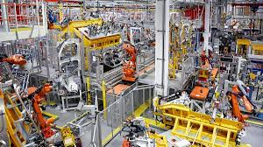Some problems are so complex that it would be impossible for humans to calculate or would take too long to calculate. Computers help solve these complex problems in a timely fashion.

* Weather prediction - Earth has an extremely complex weather system, and computers gather all of the variables and create weather reports.
* Product simulations - Before some products go into development, computers simulate how they would work in the real world. By creating a simulation, a company or government agency can make adjustments before the product goes into development.
* Big data simulation - With cheap data storage companies can now store a massive amount of data. With this big data, a computer can find unknown patterns.